**Getting Started**: Navigate to workbc.ca

* Jobs and Careers > Explore Careers > Career Compass Quizzes
* 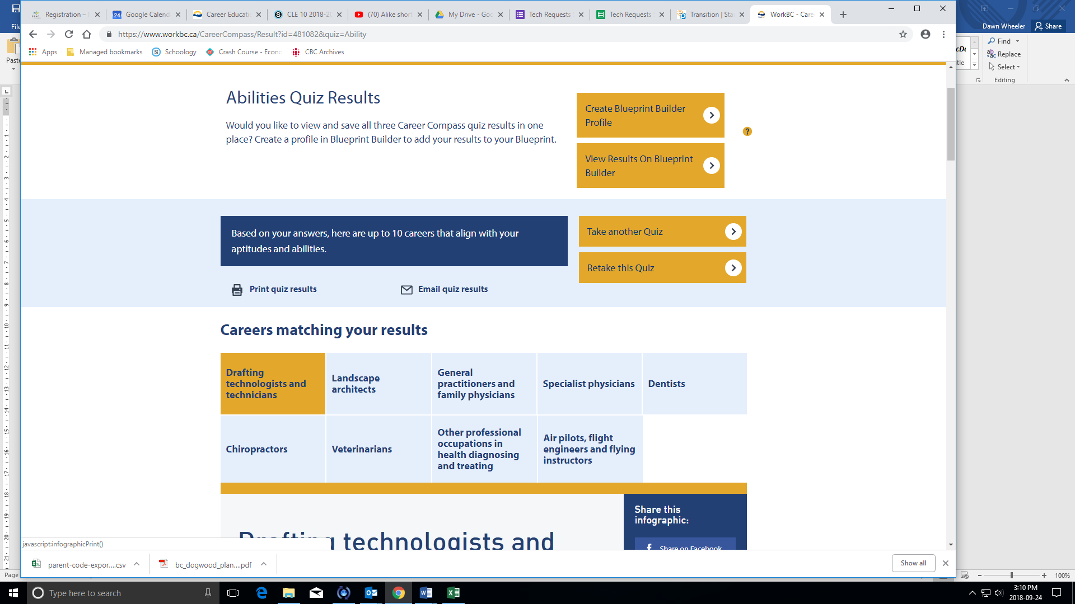Select **Career Compass** to explore you career direction and to take the 3 Career Quizzes
  + Open the “**Abilities Quiz**” and answer all 39 questions. After completing this quiz, choose “**Print quiz results” and choose “Save as PDF”** as your printer and save this to your Documents folder in H drive.
  + Open “take another Quiz” then select the “**Work Preferences Quiz**” and do the 50 questions. After this quiz record the top 5 careers that match your interests below. Please also follow the instructions for **saving as a PDF document** in your H drive.
  + Open “Take another Quiz” and select the “**Subject Quiz**”. In this quiz you are asked to select your 5 strongest subjects from the different categories. Again **print your results to “Save as a PDF” and save to your H drive**.

|  |  |  |  |  |  |
| --- | --- | --- | --- | --- | --- |
| Top 5 Careers: Abilities | 1. Aircraft Assemblers and Aircraft Assembly Inspectors | 2. Contractors and Supervisors, machining, metal Forming, Shaping and Erecting trades and related Occupations | 3. Computer Network Technicians | 4. Animal Health Technologists and Veterinary Technicians | 5. Gas Fitters |
| Top 5 Careers: Work Preferences | 1. Painters, Sculptors, and other Visual Artists | 2. Industrial Designers | 3. Other Professional Occupations in Health Diagnosing and Treating | 4. Paramedical Occupations | 5. Technical Occupation-ns in Geomatics and Meteorology |
| Top 5 Careers: Subjects | 1. Financial Auditors and Accountants | 2. Accounting Technicians and Bookkeepers | 3. Information Systems, Analysts, and Consultants | 4. Computer Programmers and Interactive Media Developers | 5. Lawyers and Quebec Notaries |

* Once you have completed this you will be provided with “**Your Top Industries**” and the Common careers that match those Industries. Take an in-depth look at minimally 2 different careers.
  + Read through the “**Career Outlook”, “Where are people in this career employed”, “So how do we get there” and “explore your options”**

1. Click through to the regions where the jobs are. Could you see yourself living in one of those areas if it is not where you live now? Why or why not?

For most jobs, yes, I can see myself living in the areas because in the lower mainland, on average 70 % of the careers were in the Lower Mainland and Surrey had some of those careers.

1. Are there job prospects in locations you are interested in living? Would you make the salary you were expecting?

There are job prospects in the area I am interested in living, but the salary is not as much as what I expect. My expectation was the salary to be around $80,000 to $100,000 a year but it was about $65,000.

1. What is the annual growth? Is the unemployment rate trending up or down?

The annual growth of the careers that I have chosen, the unemployment rate goes up on average by 0.6 % in the next 5 years from 2019 and going down 0.3 % in the next 5 years from 2024 to 2029.

*To understand what it is like to live somewhere else, you could look at the Explore B.C. regions in Career Compass.

*At the bottom of the page you can get more in-depth information by clicking on the “learn more at WorkBC.ca” link

*Use the information provided to help you complete you career investigation chart